 The Department of Labor (OSHA) has stepped up to protect workers from heat risks with a newly proposed rule - the Heat Injury and Illness Prevention in Outdoor and Indoor Work Settings rule. The establishment of this new rule comes as no surprise to safety professionals. OSHA began its rule-making process in 2021 and, as of June 2024, had conducted 5,038 [**Heat NEP Federal Inspections**](https://www.osha.gov/sites/default/files/Heat-NPRM-Final-Reg-Text.pdf). This new rule will require businesses to:

* Develop a worksite heat injury and illness prevention plan
* Provide workers access to water, shade, and regular breaks
* Train employees on heat protocols
* Keep a record and report on heat incidents

The Federal Register published OSHA's proposed heat safety rule at the end of August 2024.  The public is encouraged to submit a formal comment before December 30th through  [**http://www.regulations.gov**](http://www.regulations.gov/). In this article, we’ll break down the expectations of the rule so you can proactively prepare and avoid any costly OSHA fines.

This new rule is expected to**impact all indoor and outdoor work affected by heat at or above 80°F**except for:

* Firefighting
* Search and Rescue
* Emergency Response Crew
* Telework
* Sedentary indoor work
* Work performed indoors or in vehicles with temperatures below 80°F
* Workers exposed to high heat for 15 minutes or less in a 60-minute period
* Work with no exposure to heat

What will OSHA's heat safety rule require from employees?

The heat safety rule has several requirements that must be met. First, because each industry faces different hazards, employers must conduct a **heat hazard identification assessment** that identifies potential long-term and immediate risks.

**Risks Based on Heat Index Levels**

|  |  |  |  |
| --- | --- | --- | --- |
| **Caution**  80-90**°**F | **Extreme Caution**  90-103 **°**F | **Danger**  103-125**°**F | **Extreme Danger**  125 **°**F or higher |
| Risk of fatigue | Risk of heat stroke, heat cramps, or heat exhaustion | Heat cramps or heat exhaustion is likely | Heat stroke is likely |

Based on their findings, employers must develop a**Heat Illness and Injury Prevention Plan**in collaboration with non-managerial employees. The plan should include **emergency response protocols** and made accessible to workers in a language they understand. All workers and supervisors must be trained on the plan and taught[**how to spot early signs of heat-related illness.**](https://aligntech.co/blog/the-ultimate-guide-to-heat-safety-in-construction#types-of-heat-related-illness)

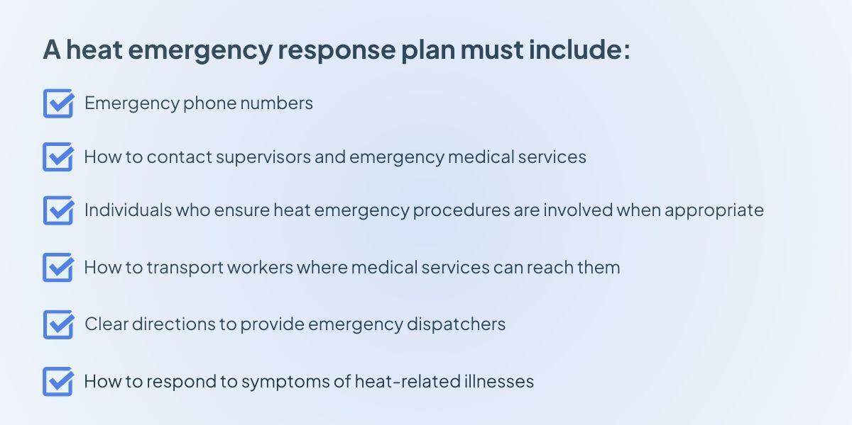

OSHA's heat safety rules will also mandate several preventative measures be taken on work sites based on two threshold levels: the Initial Heat Trigger ( 80° F  heat index or equivalent) and High Heat Trigger (90° F heat index or equivalent). The preventative measures will:

* **Availability of cool drinking water**: Employers must ensure that water is readily available and encourage workers to stay hydrated
* **Scheduled rest breaks**: The frequency and duration of breaks should increase with rising temperatures with paid breaks offered as needed.
* **Cool rest areas:** Shaded or air-conditioned rest areas must be provided to workers to take breaks and recover from the heat
* **Acclimatization program**: New or returning workers should be gradually introduced to hot working conditions to build up heat tolerance safely
* **Worker observation:** All workers will be monitored for signs of heat illness
* **Regular communication**: Ensure a two-way communication system between workers and supervisors. And display warning signs for high-heat areas.
* **Heat monitoring**: For outdoor work, employers must track local heat index forecasts or measure heat index/ wet bulb globe temperature. For indoor work, potential heat exposure zones must be identified and a monitoring plans must be implemented.

Lastly, to ensure the effectiveness of the heat safety plan, employers must conduct regular audits and maintain an incident reporting process for all heat-related illnesses and near-misses. This process should include:

* **Regular Safety Audits**: Conduct periodic audits to evaluate the effectiveness of heat safety measures and identify areas for improvement.
* **Incident Reporting:** Implement a system for reporting heat-related incidents and near-misses. This data should be analyzed to identify trends and prevent future incidents.

**Source of information, Safety Report.**